
11th August 2025
Via Teams

Start 6.30pm
Board Minutes

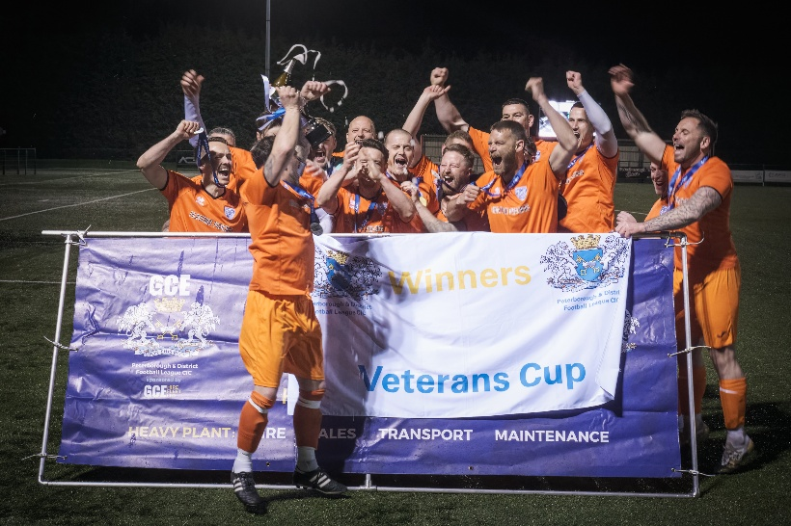
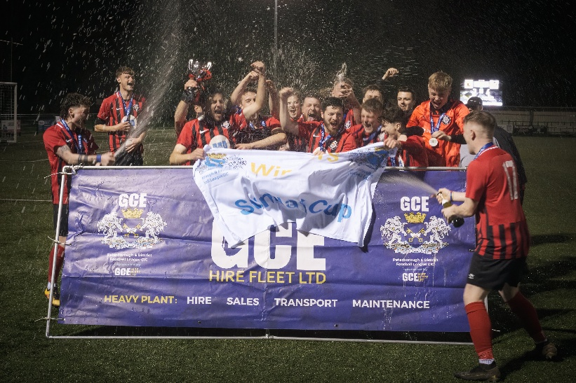
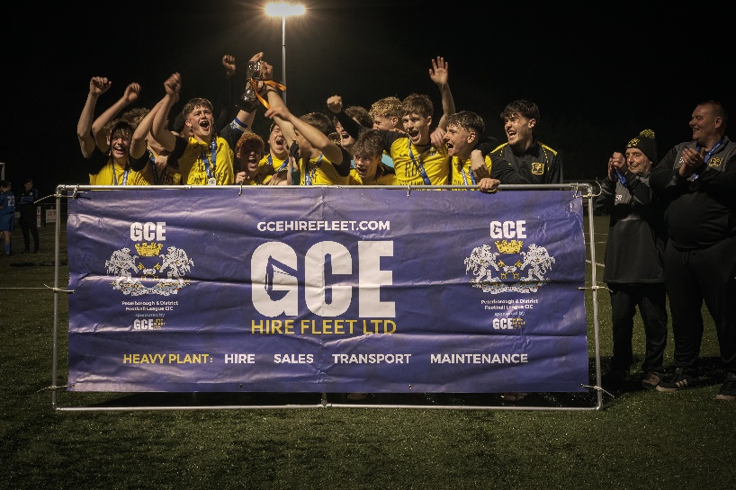

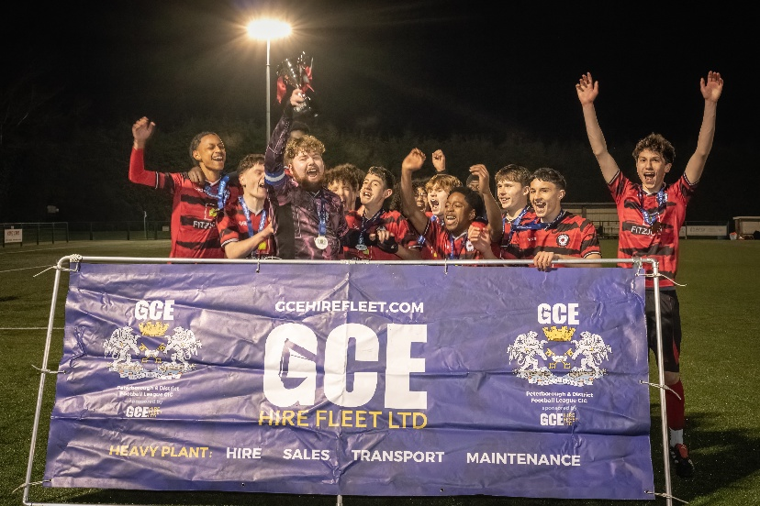
Junior Cup Winners – South Lincolnshire Swifts FC
Veterans Cup Winners – Eynesbury Rovers Veterans
Sunday Cup Winners – Stanground Cardea Sports Sunday 1st
U18 Cup Winners – Ramsey Town U18
U16 Cup Winners - Crowland Junior U16
U15 Cup - Winners Park Farm Pumas U15 Red
Cup final winners

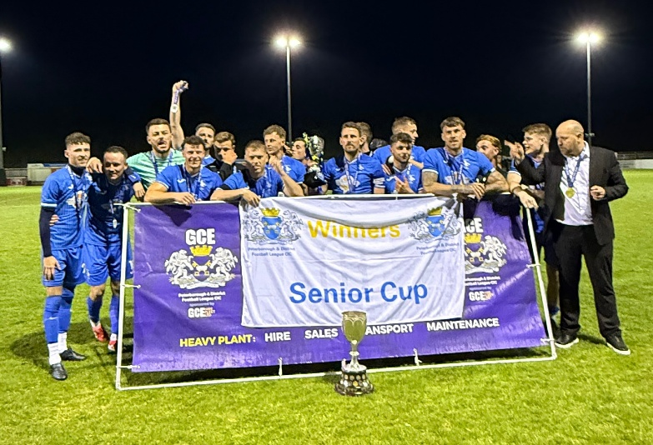
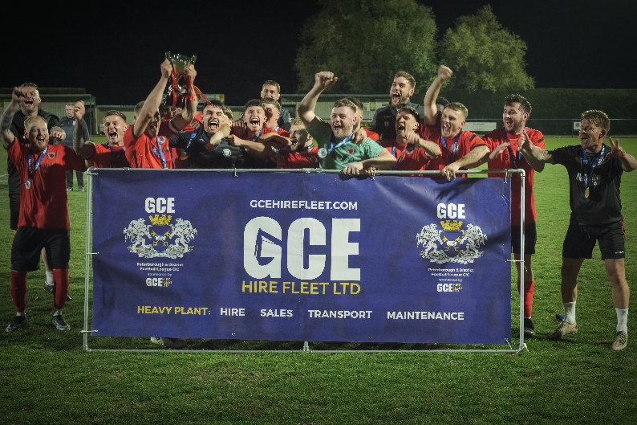

Senior Cup Winners – Warboys Town FC
Challenge Cup Winners – Netherton United FC

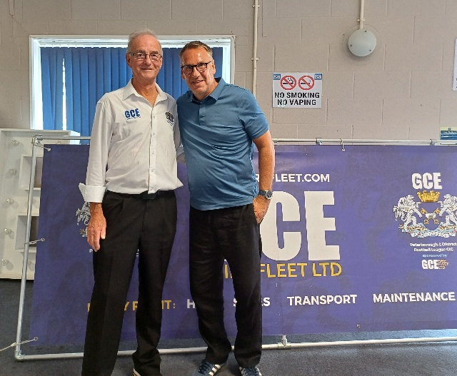
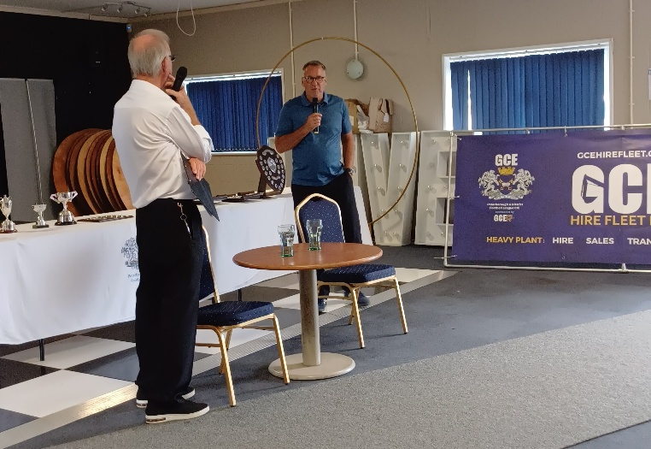

In Attendance: A Poulain (Chair of the League), P Spridgeon, R Walker (Finance Director), D Barfoot (Disciplinary Director) I Hughes (Vice Chair/Facilities Director), T Mitchell (League Cup Director), M Cowdell, and D Harris (Co-opted Member)

Apologies Received: W Newey (League Secretary), J Shaw (Development Director), J Fenton (Independent non-executive), P Clarke, D Mitcham, P Butler.

The reasons for the absence of these members were accepted by the Board.

Declarations of interest: If an item is raised that a Board Member has a direct interest, e.g., Club, then it shall be declared, and the member(s) should take no part in the discussion.

Call to Order – Quorum Present

Chair’s opening remarks
The Chair opened the meeting and welcomed everyone to the Board meeting. Our thoughts are with the family of Trevor Bass League Vice President who passed in July.

Last season ended with all cups being played to a conclusion and extremely satisfactorily. Thanks to Pete for his efforts not just last season but for all the seasons he was Cups Director. Trevor, you have big shoes to fill, but I am sure the cups committee will step up to help.

The Divisions again were completed on time although towards the end of the season clubs seem to decide games were not worth playing so forfeit them, that’s a shame given oppositions wanting to play.

The AGM went well with the addition of our guest Paul Merson who gave his time generously staying to accommodate questions and photographs.

Moving on to the new season, which is just about to start, I would like to wish all teams the very best in whatever they seek to achieve. If any clubs need help, the office and the committee are available please call and ask.

Reminder to Clubs to apply to the PDFL Community Fund, application https://forms.gle/U6d92R962tGLnpeV7

Discussion took place on ideas on how to recruit new Board Members and take part in the League. Social Media advert to be arranged.
Board and committee members are asked to supply a short Bio of how they became members.
It was agreed that we do not need additional Directors only meetings, as everything is discussed at our bimonthly meetings

Board Minutes
- 18th May 2025

Discipline Minutes
- 7th May 2025
- 20th May 2025
- 2nd June 2025
- 12th June 2025
- 8th July 2025

The Minutes of the above meeting were agreed and signed as a true and correct record.

Matters arising from previous meetings.
None

A. Operations – League Secretary Report
- League Safeguarding and Welfare Update:
    - Updated

- Marketing and Communication
    - New League website has been launched, please check out pdfl.co.uk
    - Veo licence ends 25th February 2026, we have cancelled the subscription moving forward. They do not offer a monthly subscription, so we will not be doing the highlights for the Cup Finals. Any club interested in buying the camera, please contact Wendy Newey at the office. Remember a licence needs to obtained for use of the equipment.
    - We had a person volunteer and record matches at the start of the 2024/25 season, who was with this for 6 months, his video highlights received 1,498 views. He has now gone onto work in football. We had another volunteer who helped with the last cup finals, who has now gone to do media work for a club.

Cup Finals 2024/25 | Views on YouTube
League Cup Final | 209
U15 Cup Final | 378
U16 Cup Final | 470
U18 Cup Final | 303
Sunday Cup Final | 76
Veterans Cup | 57
Junior Cup | 230
Challenge Cup | 78
Senior Cup | 28

- Equality, Diversity and Inclusion Lead
    - Nothing to report
- Board Meeting dates for Season 25/26
    - 11th August 2025
    - 13th October 2025
    - 8th December 2025
    - 9th February 2026
    - 13th April 2026
    - 18th May 2026

- 2025-26 AGM will be on the 20th June 2026 at Yaxley FC 1pm.
- Email received from Tydd FC requesting permission to enter the Spalding Inter Services Competition – Accepted
- We applied and received Mixed Gender Dispensation Approval for the PAN Disability Divisions.
- We have removed Dragonfly FC from the League, the club failed to pay league fees and failed to affiliate with County FA, also failed to reply to all correspondence.
- We are working with FA Wheelchair to set up a powerchair Division for the East of England Powerchair, covering Ipswich, Norwich, Sussex, Cambridge and Northampton. One festival this season with league ready for season 2026/27.
- Referee and Fixtures Reports: -
Referee Report: -
- Migration over to Centre Circle from RefSec for referee assignments has begun. We currently have 108 referees registered with us and are currently pushing in for more.
- Centre Circle Guides
Team Manager Sign-Up Tutorial
How Managers Confirm Pre-Match Details With Referees In Centre Circle
Fixture Report: -
- Fixtures have been released to all Saturday clubs up to the end of December.

B. League Cup Committee Director Report
Uppingham Town FC as Premier Division Winners played Warboys Town FC the winners of the Senior Cup Final in the League Cup on 1st August 2025. With Uppingham Town FC becoming champions, winning the match 5 – 1.

2024/25 Final Cup Final income and expenditure circulated to Board members.

Season 2025/26
Cup | Date/Time | Venue
U15 Cup | 10th March 2026 7.30pm Tuesday | Yaxley FC
U16 Cup | 12th March 2026 7.30pm Thursday | Yaxley FC
U18 Cup | 17th March 2026 7.30pm Tuesday | Yaxley FC
Sunday Cup | 19th March 2026 7.30pm Thursday | Yaxley FC
Veterans Cup | 24th March 2026 7.30pm Tuesday | Yaxley FC
Junior Cup | 1st May 2026 7.30pm Friday | Deeping Rangers FC
Challenge Cup | 5th May 2026 7.30pm Tuesday | Deeping Rangers FC
Senior Cup | 9th May 2026 Saturday KO Times to be arranged combining with UCL KO Cup | Stamford AFC
League Cup | TBC | Blackstones FC

C. Development Director Report including England Accreditation
- The PDFL Veterans vs RAF Veterans has been cancelled by the RAF due to current security alerts in the world the Royal Airforce have put a hold on all personnel movement not on operational duties, hopefully rearranging for October.
- England Accredited and Respect Report
  - New Clubs that have not achieved the award, and therefore need to complete: -
    - Athletic FC
    - Bolt FC – working towards
    - Kings Delph United FC
    - Littleport United FC – working towards
    - Stanton FC

  - Existing Clubs that have not achieved the award, therefore invoiced for additional costs: -
    - Alconbury Weald FC

D. Finance Director Report
- Profit & loss and Balance Sheet as at the 9th July 2025 circulated to Board members and approved by the Board.

E. Facilities Director/Vice Chairman Report
I will be contacting all new clubs over the first few weeks of the season to see how they are doing.
Also, I will be conducting spot visits to all Premier Teams during the season.

F. Discipline Director Report
We have set up a new system for raising charges and producing outcome letter and Discipline Minutes.
Discipline Dates for the Season: -
20th October 2025
15th December 2025
16th February 2026
20th April 2026

G. Any Other Business
Notice of any other business must be submitted to the Secretary in advance of the meeting.

None

The Chairman thanked the Board members for their attendance and ended the meeting at 7.45pm.

A Poulain
Chair of the League

The next meeting of the Board will be held on 13th October 2025 via Teams at 6.30pm.

