
13th October 2025
Via Teams

Start 6.30pm
Board Minutes


August and September Combined 2025 Team of the Month
Premier Division – Netherton United FC
Division One – Long Sutton Athletic FC
Division Two – Stanground Cardea Sports FC
Division Three – Thorpe Wood Rangers FC
Division Four – Stanton FC

Sunday Division One – Stanground Cardea Sports Sunday Firsts
Sunday Division Two – Glinton & Northborough Sunday

Under 18 Division One – Ramsey Town U18
Under 18 Division Two - Stamford AFC Young Daniels U18 Yellow
Under 18 Division Three – Long Sutton Athletic U18
Under 16 Division One – Deeping Rangers U16
Under 16 Division Two – Thurlby Tigers U16
U16 Division Three – Ketton Sports U16
Under 15 Division One – Boston United Community U15 Amber
Under 15 Division Two – Stamford AFC Young Daniels U15 Red
Under 15 Division Three – Peterborough Eagles U15 Blue
U15 Division Four – FC Peterborough U15
U15 Division Five – Crowland Juniors U15

Sportsmanship/Fair Play Team of the Month
Saturday – Stamford AFC Reserves
Sunday – Boston Colts FC
Under 18 - Netherton United U18 Red
Under 16 – Boston United Community U16 Blue
Under 15 - JFC Boston U15

Ground of the Month – Fc Peterborough Reserves

Referee of the Month – Terry Spriggs
Youth Referee of the Month – Ben Carr

Monthly Awards



In Attendance: A Poulain (Chair of the League), P Spridgeon, R Walker (Finance Director), W Newey (League Secretary), D Barfoot (Disciplinary Director) I Hughes (Vice Chair/Facilities Director), T Mitchell (League Cup Director), P Butler, P Clarke, D Harris (Co-opted Member), and M Cowdell

Apologies Received: D Mitcham, J Fenton (Independent non-executive), and J Shaw (Development Director)

No Apologies: None

The reasons for the absence of these members were accepted by the Board.

Declarations of interest: If an item is raised that a Board Member has a direct interest, e.g., Club, then it shall be declared, and the member(s) should take no part in the discussion.

Call to Order – Quorum Present

Chair’s opening remarks
The Chair opened the meeting and welcomed everyone to the Board meeting.

Our condolences with Leverington Sports FC and family of Steve Fisher Chair and stalwart of the Club who has recently passed away. Steve’s funeral will be held on 30th October at Leverington Church, and Leverington Sports will be holding a celebration of life for Steve at the Leverington Sports v FC Peterborough Reserves Premier Division match on 15th November.

Dan Harris General Manager GCE Hire Fleet Ltd
As a family run business, GCE Hire Fleet has always believed that supporting our local communities is just as important as delivering for our customers. Football at grassroots level plays a huge role in bringing people and communities together, creating opportunities, and inspiring the next generation – and the PDFL is a fantastic example of that.

When the opportunity arose to become the long-term sponsor and partner of the league, I felt it was important for us to not only support the league financially, but to also try and play an active role in helping it grow and thrive alongside a team of people who care deeply about the game

Being asked to join the PDFL board was a real honour, and has given me a real appreciation of how much goes on behind the scenes to keep local football alive, and I’d encourage anyone who shares that passion for football or local community development to get involved. The board is always open to new members, young and old, and people can bring a wide range of skills to the table – whether that’s social media and marketing, business development, administration, finance, event organisation, or simply fresh ideas and enthusiasm. All of these make a real difference to how the league runs and how it continues to thrive.

For me, it’s been rewarding both personally and professionally – meeting new people, learning from others, and helping ensure grassroots football in our region continues to flourish for years to come.

Board Minutes
- 18th May 2025

Discipline Minutes
- 19th August 2025
- 26th August 2025
- 3rd September 2025
- 15th September 2025
- 25th September 2025
- 2nd October 2025
- 6th October 2025

The Minutes of the above meeting were agreed and signed as a true and correct record.

Matters arising from previous meetings.
None

A. Operations – League Secretary Report
- League Safeguarding and Welfare Update:
    - Updated
- Marketing and Communication
    - New League website to be launch in the closed season.
- Equality, Diversity and Inclusion Lead
    - Nothing to report
- Board Meeting dates for Season 25/26
    - 8th December 2025
    - 9th February 2026
    - 13th April 2026
    - 18th May 2026
- 2025 AGM will be on the 20th June 2026 at Yaxley FC 1pm.
- Email sent to Division One Clubs reminding them of Rule 4A Present Division One (Saturday) Clubs applying to be placed in the Premier Division must do so in writing to the Company Secretary by 31st December in the relevant year. A non-returnable fee in accordance with the Fees Tariff must accompany all such applications otherwise the application will lapse. A Ground inspection will be carried out by the League’s Facilities Committee by 28th February and applicant Club(s) will be given until 31st March to complete any changes necessary to bring facilities up to the required standard. A second inspection will be carried out to ensure that the required changes have been made. (See details of requirements on the League APP and Website). Applications received from: -
    - Long Sutton AFC – Invoiced, inspected works to be carried out before 31st March re inspection.
    - Stamford AFC Reserves – Invoiced, inspected works to be carried out before 31st March re inspection.
    - Ketton Sports - Invoiced, inspected works to be carried out before 31st March re inspection.
    - Yaxley Reserves – Invoiced, Step 5 facility.
    - Bourne Town Reserves – Invoiced, Ian emailed
- Email received from Tydd FC requesting permission to enter the Spalding Inter Services Competition – Accepted
- Email received from The FA inviting League to the Step 5 & 6 Leagues of The FA National League System and Regional Feeder Leagues can apply to enter The FA Inter-League Cup for season 2025-26. Emailed Premier Clubs from feedback and for applications for Representative Manager we received no replies, therefore we will not be entering the FA Competition.
- We applied and received Mixed Gender Dispensation Approval for the PAN Disability Divisions.
- Application received and accepted for Godmanchester Rovers U16.
- Congratulations to Hampton United FC who won the Huntingdonshire FA Club of the Year Award, Lewis Veni of Stanground Cardea Sports FC who won the Huntingdonshire FA Young Volunteer Award, Guy Walton of Stamford AFC who received the Lincolnshire FA Valued Service Award – 20 years and Chris Seggie of Thurlby Tigers FC who received the Lincolnshire FA Long Service Award – 10 years
- Email sent to clubs on the 11th September regarding the discipline tab on the portal.

Just a reminder, now that discipline is on the portal, please ensure you keep track of the suspensions and outstanding payments. Club suspensions are activating straight away, without warning. This could mean you end up playing whilst suspended, so please ensure you are up to date with all payments and suspensions.

All discipline notifications are sent to the Club Secretary only.

Notifications are sent when;
- A Charge is Raised
- A Charge Response Overdue Notification
- Charge Results Notification
- Claim Results Notification
- Payment Overdue Warning Notification
- Payment Overdue Suspension Warning Notification

There are two email notifications sent on a weekly basis (examples below);
- Suspension Summary Email Notification
- Case Summary Email Notification

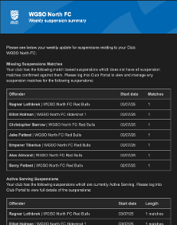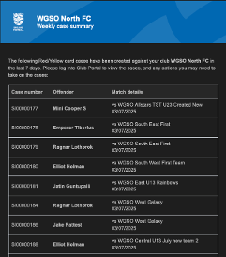
Please check your spam folders if you are not receiving the notification emails.

Please also ensure you are clearing player’s suspensions by adding the matches. If you are struggling with this, please let us know and contact your county FA.
- We are working with FA Wheelchair to set up a powerchair Division for the East of England Powerchair, covering Ipswich, Norwich, Sussex, Cambridge and Northampton. One festival this season with league ready for season 2026/27.
- Registrations: Across the League, we have 5,342 players registered (as of 15th September).

An email was sent on the 26th June regarding registration information to all clubs.
Just a reminder regarding transfers, “Formal written notice of approach need be given by (A) a Saturday Club only to all Saturday Clubs; (B) a Sunday Club only to all Sunday Clubs; and (C) a midweek Club only to all midweek Clubs;” This is irrespective of if the club is in our League.

Please ensure when you are dealing with a transfer, you send the notice of approach and waiver prior to submitting the transfer request to the League.

An email was sent on Thursday 11th September reminding clubs of the match day deadline for weekend matches, which is 12pm Friday before the match. Please ensure if you are having issues with registrations, that you contact us as soon as possible, and not just on the Friday. This way, we can help resolve the issue.

Please can a look at the link below that takes you to the Grassroots technology page for information and troubleshooting.

https://grassrootstechnology.thefa.com/support/solutions/folders/48000693753

Referee Report: -
Referees’ assignments continue through Centre Circle. Officials are confirmed on the app ahead of time with teams and posted on to Full Time the day of the fixtures.
Our Saturday and Veterans games continue to be fully covered, with around 79-80% of Sunday Adult and Youth games having assigned cover ahead of time.
Fixture Report: -
Leverington Sports will be holding a celebration of life for Steve Fisher at the Leverington Sports FC v FC Peterborough Reserves match on 15/11/2025
- Fixture Proposal for 2026/27 Season – Discussion Point
Proposal put to Board regarding start dates for next season, Secretary to email Clubs for feedback.
- With a number of Under 18 teams withdrawing from the league from August to September, all the teams were approached with two proposals make sure that they a sufficient fixture for the season.
  - Option One - Teams to play each other three times instead of two
  - Option Two – The three divisions to be consolidated into two divisions
We gave them from 18th August to 25th August to respond with their preferences, with the majority choice being actioned.
From the responses, the majority decision was Option One. The fixtures have been implemented into the schedule.
- PAN Disability
Due to number of teams withdrawing from the competition, our PAN Disability football match day on 21st September will be run as a one-day festival for Adults and Under 16 teams at Yaxley FC.
Due to lack of applications, the October 19th Pan Disability Festival was cancelled.
We’ve begun pushing out applications and advertising for the nest PAN Disability event on 30th November, which will be held at One Leisure St Ives.

B. League Cup Committee Director Report

Season 2025/26
Cup | Date/Time | Venue
U15 Cup | 10th March 2026 7.30pm Tuesday | Yaxley FC
U16 Cup | 12th March 2026 7.30pm Thursday | Yaxley FC
U18 Cup | 17th March 2026 7.30pm Tuesday | Yaxley FC
Sunday Cup | 19th March 2026 7.30pm Thursday | Yaxley FC
Veterans Cup | 24th March 2026 7.30pm Tuesday | Yaxley FC
Junior Cup | 1st May 2026 7.30pm Friday | Deeping Rangers FC
Challenge Cup | 5th May 2026 7.30pm Tuesday | Deeping Rangers FC
Senior Cup | 9th May 2026 7.00pm Saturday  (UCL KO Cup at 3pm) | Stamford AFC
League Cup |  | Blackstones FC

Match Official appointments to be agreed with Committee and Matt to arrange Cup Draws with GCE, Alan and Trevor.

C. Development Director Report including England Accreditation
- England Accredited and Respect Report
  - Clubs that have not achieved the award: -
    - Alconbury Weald FC
- England Accredited and Respect Report
  - New Clubs that have not achieved the award, and therefore need to complete: -
    - Athletic FC
    - Bolt FC
    - Kings Delph United FC
    - Littleport United FC
    - Stanton FC

D. Finance Director Report
- Profit & loss and Balance Sheet as at the 29th September 2025 circulated to Board members and approved by the Board.

E. Facilities Director/Vice Chairman Report
Have spoken to new teams to check how they were doing.
Completed a couple of Premier division spot checks, notably at Stamford Bels (will elaborate at meeting)
We have had applications for promotion to the Premier Division as per Secretary Report. All are aware of the requirements to reach the criteria.
Visited Sutton Bridge United FC and met with the Parish Council, project manager and Club Secretary re changing rooms new build
F. Discipline Director Report
The Board are concerned about the number of clubs that are NOT responding to communications, especially discipline, which causes a sanction of minimum £25 (first offence) to be raised. Please can all clubs save themselves some money by replying to correspondence as requested.
Discipline Dates for the Season: -
  - 20th October 2025
  - 15th December 2025
  - 16th February 2026
  - 20th April 2026

G. Any Other Business
Notice of any other business must be submitted to the Secretary in advance of the meeting.

None

The Chairman thanked the Board members for their attendance and ended the meeting at 7.15pm.

A Poulain
Chair of the League

The next meeting of the Board will be held on 8th December 2025 via Teams at 6.30pm.

Appendix One: PAN Disability posters advertising November PAN Disability festivals

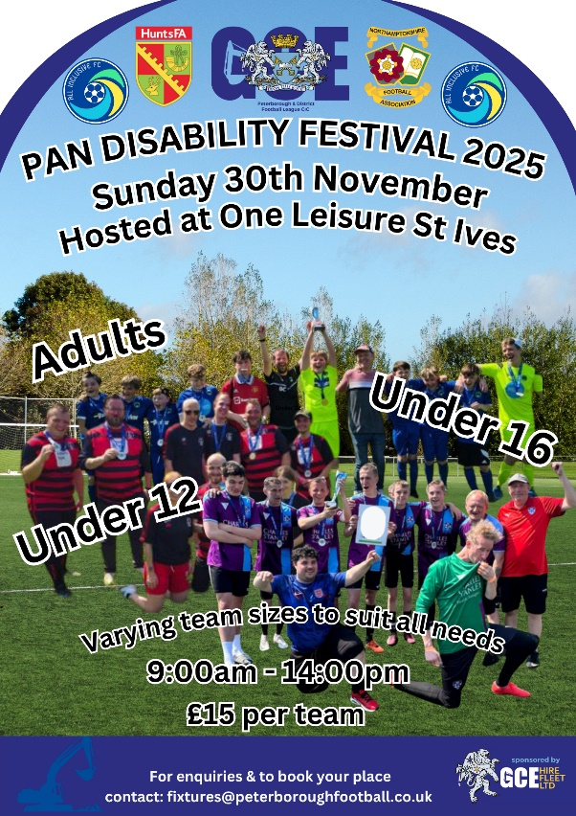

Appendix Two: Link to PAN Disability October application form

https://forms.gle/zjYUSroDQSUqrybr5

Appendix Three:

Email reminder for Saturday/Sunday & Youth/ Veterans Teams regarding invoices being raised against teams failing to confirm their details on Centre Circle.

Saturday
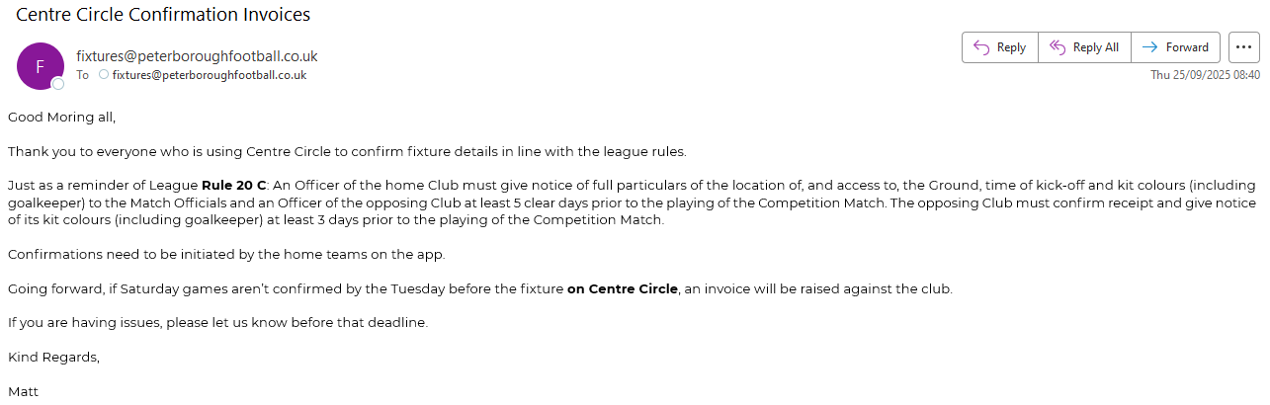
Sunday/Youth

